**Annex 1**

**Rules of the 2nd WORLD**

**UNIVERSITY UNDERWATRE**

**ROBOT COMPETITION**

I. AUV Competition Rules 3

1. Introduction 3

1.1 Autonomous Underwater Vehicle(AUV) 3

1.2 Venue&Site 3

1.3 Requirements on AUV 4

1.3.1 Size and Weight 4

1.3.2 Power Supply 4

1.3.3 Emergency Switch 5

1.3.4 Others 5

2.Competition Tasks 6

2.1 Passing the Qualification Gate 6

2.1.1 Props Description 6

2.1.2 Instruction of Rules 7

2.2 Hitting Floating Ball 8

2.2.1 Props Description 8

2.2.2 Instruction of Rules 9

2.3 Underwater Precise Work 9

2.3.1 Props Description 9

2.3.2 Instruction of Rules 12

2.4 Rising onto the Flotation Frame 12

2.4.1 Props Description 12

2.4.3 Instruction of Rules 13

2.5 End of Competition 14

3.Scoring Rules 15

II. ROV Competition Rules 16

1. Introduction 16

1.1Remote Operated Vehicle(ROV) 16

1.2 Venue and Site 16

1.3 ROV Specifications 17

2.Task 18

2.1 Delivering feeds 18

2.2 Inspection of Hull 21

2.2.1Inspecting the Hull and Clean up the Damaged Part 21

2.3 Collecting Seabed Ores 23

2.4 Precise Operation 25

2.5 End of Competition 27

3.Scoring Criteria 28

III. Innovative Concept Track Rules 30

1. Requirements 30

2. Rules of Competition 30

2.1 Competition Process 30

2.2 Scoring Criteria 31

1. **AUV Competition Rules**
2. **Introduction**

### 1.1 Autonomous Underwater Vehicle(AUV)

AUV (Autonomous Underwater Vehicle), one of the main categories of underwater vehicles, which integrates controllers, sensors, computer software and power, has autonomous perception and intelligent decision-making capabilities, and navigates with its own power. With the ability of autonomous navigation and sailing, it can conduct large-scale navigation and detection missions, and is often used in marine aerial surveying, target search and marine exploration.

The competition tests perception and intelligent control of the AUV (Autonomous Underwater Vehicle) by examining its completion of various underwater tasks. The tasks of competition include: passing the qualification gate, hitting floating ball , underwater precise work and rising onto the flotation frame by tracing acoustics signals. Underwater navigation markers with QR codes will help and guide the AUV during the first 3 tasks; the light beacon or a 37.5kHz acoustic beacon will guide the AUV in the final task.

### 1.2 Venue&Site

Site Size: length not less than 20m, width not less than 8m, depth from 1.3m to 2.2m.

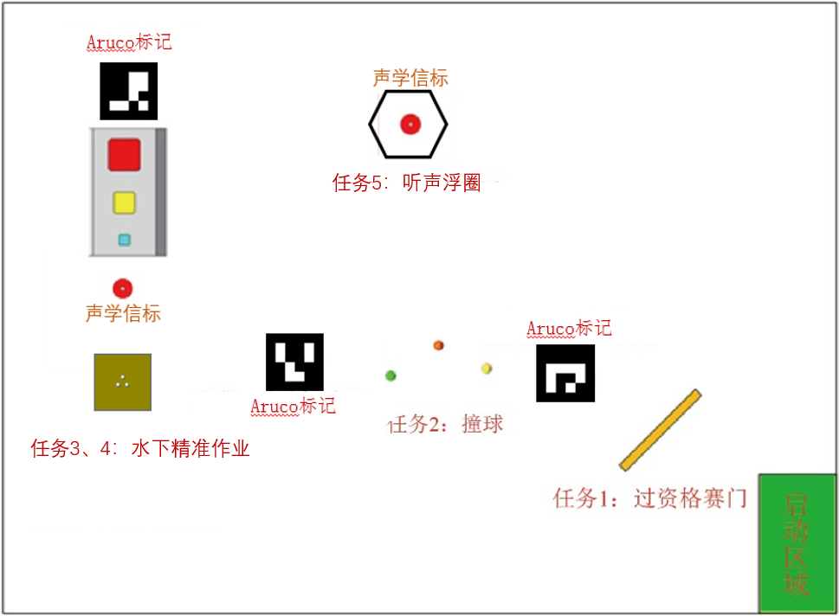

Figure 1 Competition Site Diagram

### 1.3 Requirements on AUV

#### 1.3.1 Size and Weight

The vehicle must fit into a cube size of 1000mm*1000mm*2000mm. Vehicles weighing 45 kg or more are not allowed to compete.

The team can use 2 vehicles if their total mass and dimensions do not exceed the specified limits.

1.3.2 Power Supply

The power supply can only be rechargeable battery, with the voltage not exceeding 72V. It is forbidden to use a 220V AC power supply.

#### 1.3.3 Emergency Switch

Each vehicle must have a reliable security (emergency) switch to shut down the system and stop all propellers during an emergency. The switch should be placed in a prominent position on the surface of the vehicle, which can be easily operated by the diver in case of emergency.

#### 1.3.4 Others

1. During the competition, except the balls for competition, no parts or accessories can be separated from the vehicle and nothing can be thrown into the pool. There should also be no leakage of oil or other pollution.
2. During the competition, once the AUV (or one of the AUVs) floats onto the surface, the attempt ends. During the competition, no part of the robot shall be above the water except for the floating ring. Once any part floats onto the water, the attempts ends (according to 2.5 End of Competition). That is, during the competition, the robot can only surface once to complete the task of Rising onto the Flotation Frame.
3. The AUVs must autonomously pass all tests. Teams are prohibited from touching the water in pool with any device or using any wireless device to remotely control the vehicles.
4. Total attempt time for each team is 30 minutes, 10 minutes for debugging preparation and 20 minutes for competition. The AUV should pass the gate within 10 minutes after the starting of the race. The attempt ends when any part of the robot floats onto the surface (except Rising onto the Flotation Frame task).
5. If the participants consider that the result of the first attempt is unsatisfactory, then a second attempt may be made. When the team members announce the termination of the attempt, the 20-minute timer is suspended, and the score gained this time is invalid. The staff will salvage the robot and when it is handed over to the team members.
6. A captain for each team can be appointed to contact the judge, participate in the draw and stop the attempt, if necessary.
7. Only if all the four tasks have been completed with scores at the end of the competition, additional points can be awarded for the remaining time the 20-minute timer continues.

# 2.**Competition Tasks**

## 2.1 Passing the Qualification Gate

**2.1.1 Props Description**

The qualification gate is a rectangular frame made of red PVC pipes, the inner frame size is of 2500mm x 1500mm. The specific dimensions are shown below:

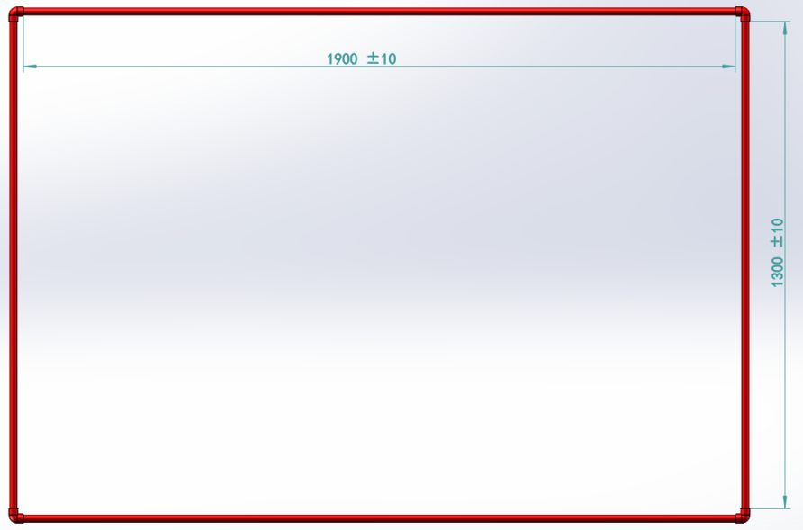

Figure 2 Qualification Gate

Behind the gate, there is a plate with a Aruco code for the positioning and guiding (as shown below). The size of the plate is 400mmx400mm. All Aruco codes are different. The rotation angle (from -180 to 180 degrees) is encrypted in the Aruco code to guide the AUV to the second task.



Figure 3 Aruco code for Positioning and Guiding

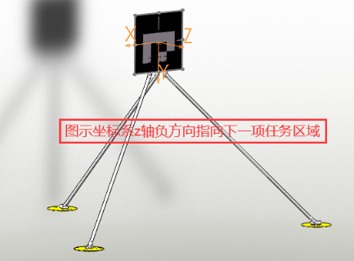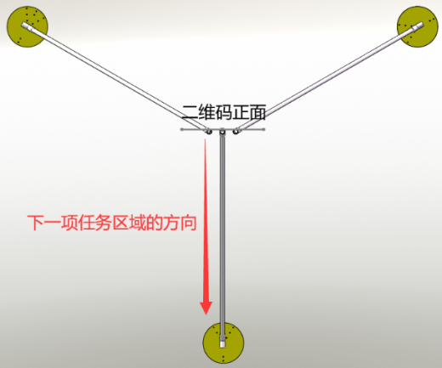

Figure 4 Layout and location of Aruco code

#### 2.1.2 Instruction of Rules

The AUV completes the dive in the starting area and begins the tasks, passing through the qualifying gate first and scoring. No points will be awarded for failure to pass the qualifying gate.

Here is the formula to calculate the score of passing the gate:scores = base points + additional points. Passing the gate underwater, the vehicle can get both base points and qualification of attending the subsequent tasks of the game.

Additional points of skilled passing are given for rotating 2 circles in the same direction while passing the door, including horizontal rotation (z axis) and roll rotation (x or y axis). Certain points are awarded for each 90° rotation, but are also deducted for reverse rotation. Full marks are awarded for 2 circles.

Note: Horizontal rotation (z axis) : 5 points each 90°, full score is 40 points.

Roll rotation (x or y axis): 10 points each 90°, full score is 80 points.

## 2.2 Hitting Floating Ball

### 2.2.1 Props Description

Three floating balls of different colors will be placed in the pool, each tied to a line with the other end fixed to the bottom of the pool by a heavy object. The distance between the floating balls and the water surface is 0.6m~1.2m, and the height of the floating balls are different, as shown below:

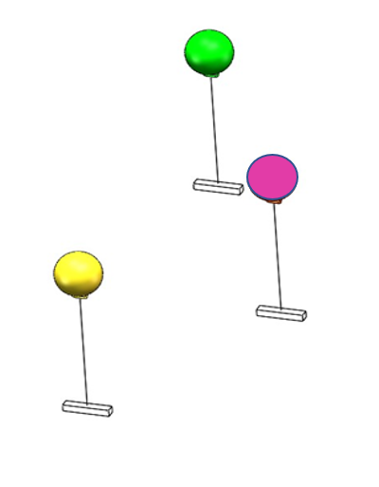

Figure 5. Schematic Diagram of Floating Ball

3 standard inflatable floats with a diameter of 20 cm are used as floating balls. Balls with the help of a rope and a load, are installed in the water at different depths. The horizontal distance between the centers of the floats is about 2m.

### **2.2.2 Instruction of Rules**

The vehicle needs to hit the floats in the water in order which were drawn before taking the competition to score points. If the vehicle doesn’t hit the floats in order, only a lower score can be awarded.

The Aruco marker after the Hitting Floating Ball task indicates the direction of the next task. The size of the Aruco code is 400mm*400mm, and the guide angle is from -180 degrees to 180 degrees.



Figure 6 Aruco Code for Underwater Precision Operation

## 2.3 Underwater Precise Work

### 2.3.1 Props Description

A display basket will be installed at the bottom of the pool. Negative buoyance exists in water. Three white balls are placed in the display basket. The dimensions are shown in the following figure:

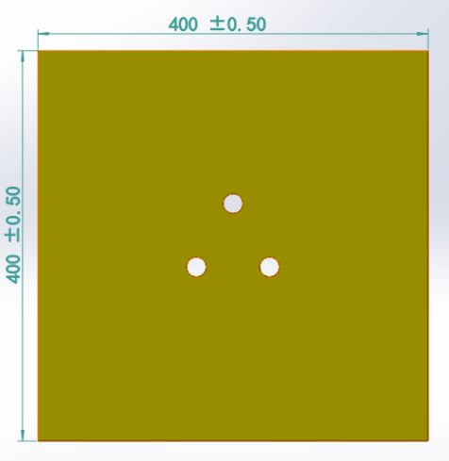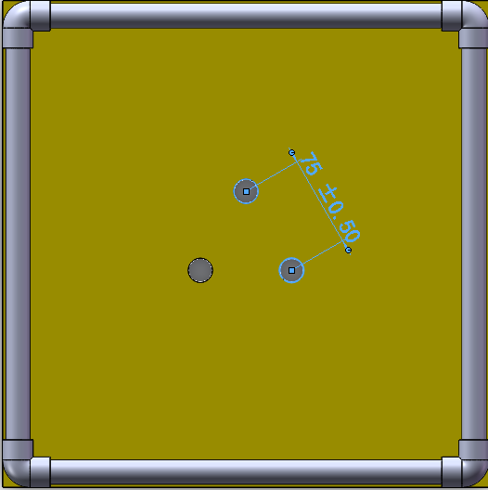

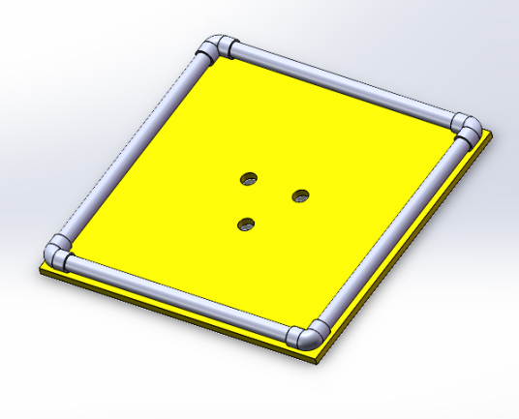

Figure 7 Underwater Golf Display Basket

A storage basket with three cells of different sizes will also be installed next to the frame at the bottom. The vehicle needs to grab the golf balls from the display basket at the bottom and put it into basket cells, as shown below:

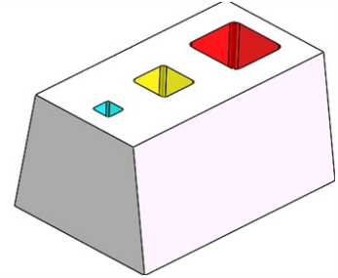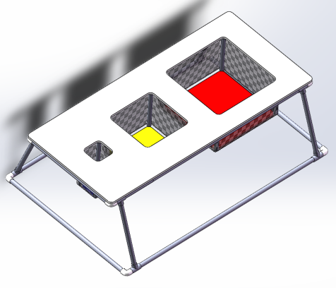

Figure 8 Storage Basket Cells

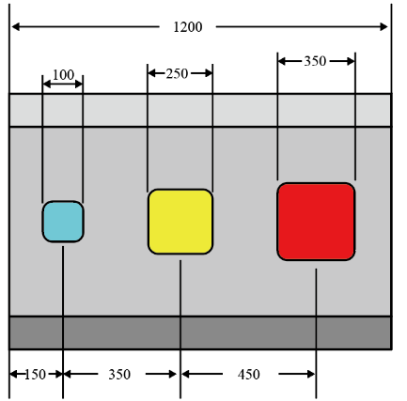

Figure 9 Schematic Diagram of the Storage Basket Size (mm)

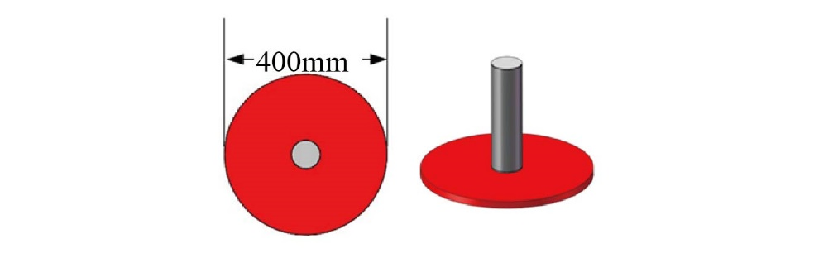

Figure 10 Underwater 30K Acoustic Beacon

The underwater precision operation area is equipped with 30k CW acoustic beacon to help the vehicle locate itself in the area.



Figure 11 Aruco Code for Underwater Precision Operation

A Aruco code is also equipped in the area, to be used to help the vehicle locate itself. Specific Aruco marker need to be further determined.

### 2.3.2 Instruction of Rules

Besides one yellow golf ball carried by the vehicle, extra balls (white) can be caught from the display basket and cast into the basket cells.

The vehicle can get scores by casting balls in any cells of the basket. The smaller the cell is, the more points the vehicle can get.

## 2.4 Rising onto the Flotation Frame

### 2.4.1 Props Description

The floating frame is a regular octagon made up of eight PVC pipes of about 620mm in length.

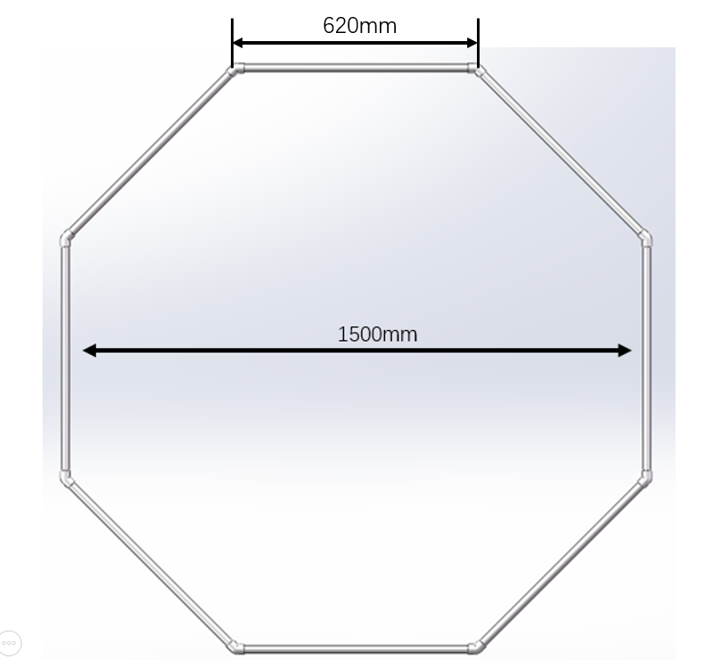

Figure 12 The Floating Frame Diagram

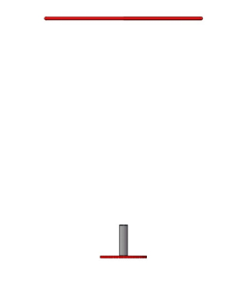

Figure 13 Schematic Diagram of Props for Rising through Floating Frame Guided by Acoustic Beacon



Figure 14 37.5k CW Signal Acoustic Beacon

A 37.5k CW signal acoustic beacon is arranged below the frame for the guidance of the vehicle. Meanwhile, there is a red plate at the bottom of the acoustic beacon that helps the vehicle locate itself. The diameter of red plate is 400mm.

### 2.4.3 Instruction of Rules

The vehicle needs to emerge from the floating frame, which is basically fixed to a designated position on the surface of the water, to complete the task. Below the floating frame is an acoustic beacon set on a red disk, it can also be used as a means of vehicle cursor positioning.

It is judged to be a successful floating if the vehicle rises to float out of the frame and stays for more than 3 seconds. The vehicle gets full scores if it does not touch the frame, otherwise penalty points will be given.

## 2.5 End of Competition

After completing all the tasks, AUV floats onto the surface again outside the finish circle and applies for the end of the competition and the referee stops the countdown timer for 20 minutes. If all five tasks are scored, the remaining time is converted into "remaining time bonus".

The above figures are for reference only, the competition is subject to the actual.

The organizing committee reserves the right of final interpretation.

# 3.Scoring Rules

The total score is composed of work points completed within 20 minutes and remaining time bonus points, which can only be awarded if all tasks are completed within 20 minutes. The competition result is sorted according to the total score. If the scores are the same, the team with lower quality wins.

|  |  |  |
| --- | --- | --- |
| **Tasks** | **Points** | **Max. point** |
| **Task 1: Passing through the Qualification Gate** | | 100 |
| Passing through the gate | 20 | 20 |
| Passing through the gate *with rotation:*  horizontal (roll across) n*90° | +5n/+10n（n≤8） | 80 |
| **Task 2: Hitting the Floating Balls** | | 60 |
| Hitting the Balls Subsequently of 1/2/3 ball(s)  Hitting the Balls out of order | +10/+35/+60  each+5 | 60 |
| **Task 3: The Placement of Self-carrying Balls** | | 30 |
| Casting the yellow balls into the large/medium/small cell of the basket | +10/+20/+30 | 30 |
| **Task 4: Underwater Target Grab and Placement** | | 180 |
| Casting the white balls into the large/medium/small cell of the basket | +20/+40/+60 | 180 |
| **Task 5: Rising onto the Flotation Frame** | | 100 |
| Rising to float without touching  Rising to float with touching | +100  +50 | 100 |
| **Others** | | 20 |
| Additional points for the remaining time | Each 1 min +1 point,  No more than 20 points | 20 |
| **TOTAL** |  | 490 |

1. **ROV Competition Rules**
2. **Introduction**

## 1.1Remote Operated Vehicle(ROV)

Remote Operated Vehicle (ROV), also known as underwater vehicle, working under extreme circumstance of underwater, which can dive into the water to substitute human to complete the underwater operation. Owing to the harsh and dangerous underwater environment and human's diving depth limitation, underwater vehicle has served as an important tool for the ocean exploitation. The way it works is that the staff of the supported vessel provides power via connecting the ROV umbilical cable, operates or controls the ROV, observes through underwater monitor, sonar and other special equipments, and conducts underwater operations through the manipulator.

The Competition examines the underwater comprehensive operation ability of the ROV, including scouting the aquaculture area and feeding, inspecting the hull along the prescribed route, collecting seabed ores, and underwater precise operation of supplying power and starting the seabed detector.

## 1.2 Venue and Site

Pool size: 10m× 5m, depth from 1m-1.3m, as shown below:

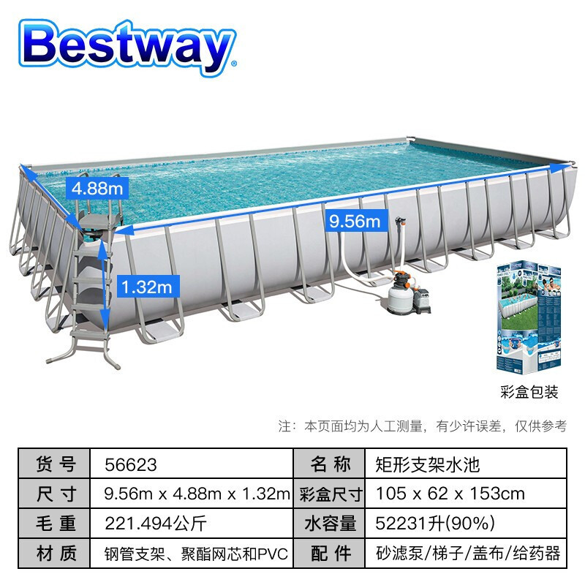



Figure 15 Site Diagram

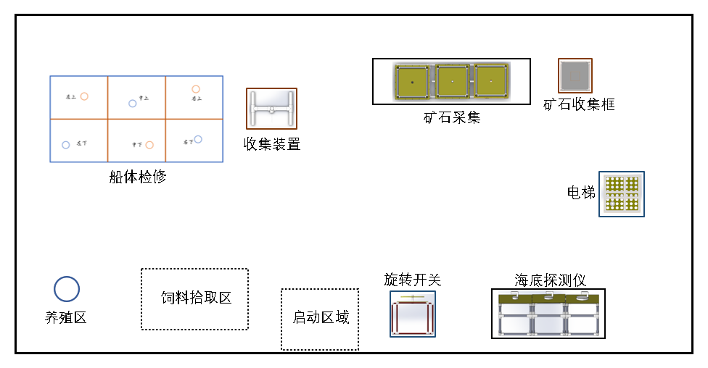

Figure 16 Competition Venue Diagram

1.3 ROV Specifications

1. Quantity: up to 1 (crawler walking is not allowed to avoid damaging the landform of the competition site)
2. The weight of the vehicle shall not exceed 25kg(weight of umbilical cable not included), otherwise it will not be allowed to participate in the competition.
3. Size: when the manipulator is retracted, the ROV shall be able to fit into a cube of 1000mm×1000mm×2000mm.
4. Number of Control Operators: no more than 2 persons and operators must be team members.
5. Number of Umbilical Cable Operators: no more than 2 persons
6. Finish time: 10 minutes
7. The manipulator need to sit in the designated position, cannot see the vehicle in the pool during operation, can communicate with the referee to ask the time, apply for stopping the game, etc.

# 2.Task

## 2.1 Delivering feeds

There is a seafood breeding area. In the ocean ranch, where the team members operate vehicle to drop feed into the breeding area.

There are two types of feed, both of which show negative buoyancy in water. One is in a feed container, and the other is a ball solid feed (with a "float") in a feed frame.

The breeding area is a cylinder with a diameter of 14cm and a height of 20cm, which is placed at the designated position at the bottom of the pool.

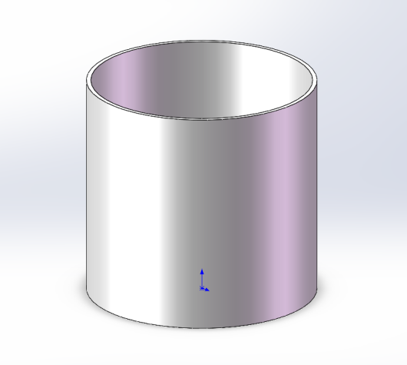

Figure 17 Breeding Area Diagram

The feed container is a 500mL plastic bottle with a counterweight and a negative buoyancy of no more than 5N in the water. It is placed in the feed picking area, as shown in the figure.

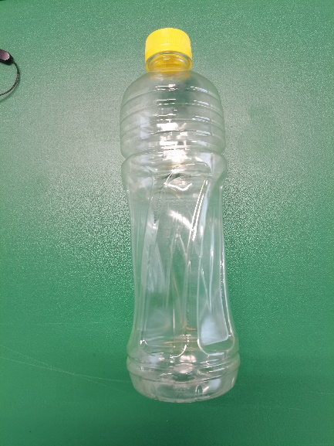

Figure 18 Feed Container Diagram

(no counterweight, certain beverage bottle)

The ball solid feed is made of "float", string and a golf ball. The feed should have negative buoyancy and sink in the bottom feed picking area. The amount of solid feed is 3 and placed in the feed frame in the feed picking area.

The "drift" is a pp board with a diameter of 150mm and a thickness of 10mm. There are two through holes with a diameter of 4mm and a center distance of 8mm, which are used to hold the string. And it shows positive buoyancy in the water.

The string should be soft and about 16cm long. A ring screw is attached to the golf ball to hold the string.

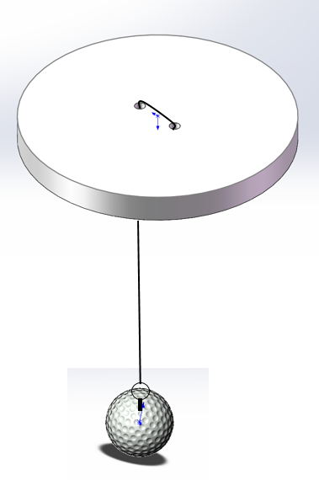

Figure 19 Ball Solid Feed Overall Diagram

The feed frame is a rectangular frame with the size of 34*15*15 (cm), which is composed of 20mmPVC tubes and net.

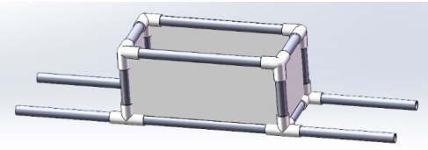

Figure 20 Feed Frame Diagram



Figure 21 Overall Side View Diagram ("float" slightly higher than the frame edge)

## 2.2 Inspection of Hull

Teams operate vehicles to inspect the underwater part of the hull, and point out the damaged part of the hull.

### 2.2.1Inspecting the Hull and Clean up the Damaged Part

The underwater part of the hull is a approximately 1.2m×2.4m blue rectangles, made up of 20mm PVC tubes. Red PVC pipe and white pipe fitting divide the rectangle into 6 areas, which are upper left, upper middle, upper right, lower left, lower middle and lower right. Each area is about 60cm×80cm rectangle, as shown in the picture.

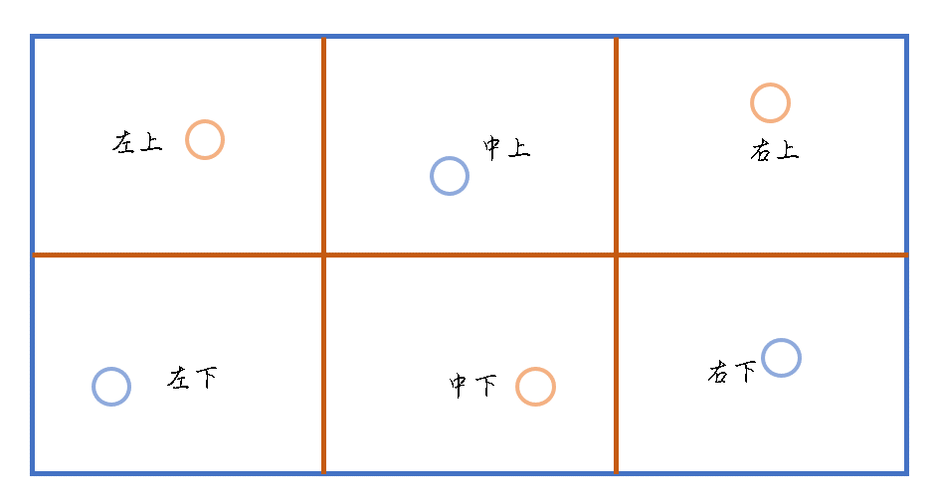

Figure 22 Diagram of the Hull

There will be 6 damaged points on the surface of the hull, which will be represented by red (blue) colored plastic rings (3 red, 3 blue). Each area has one damaged point, the corresponding color is shown in the figure above. In the process of inspection, the damaged object is picked up and hung into the collection device of the same color. Points are scored at the end of the competition based on the correct colored rings remained.

The plastic ring is made of pneumatic tubes and bolts, which have less negative buoyancy in the water and stand at the bottom of the pool. The collection device is made of 50mm diameter splicing PVC pipe, as shown in the figure.

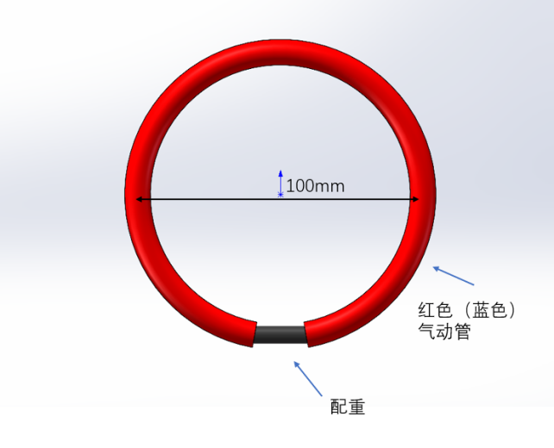

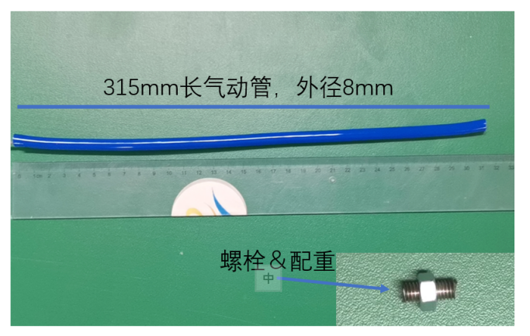

Figure 23 Damaged Point(Plastic Ring) Diagram

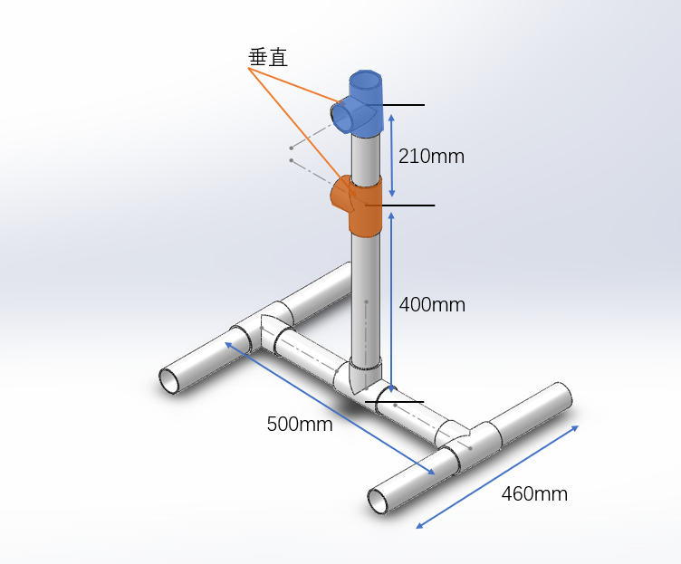

Figure 24 Collection Device Diagram

## 2.3 Collecting Seabed Ores

Different types of ores (golf of different colors) are distributed on the underwater ground and in reef gaps. Teams control the ROV to collect ores and drop them into the collection cells.

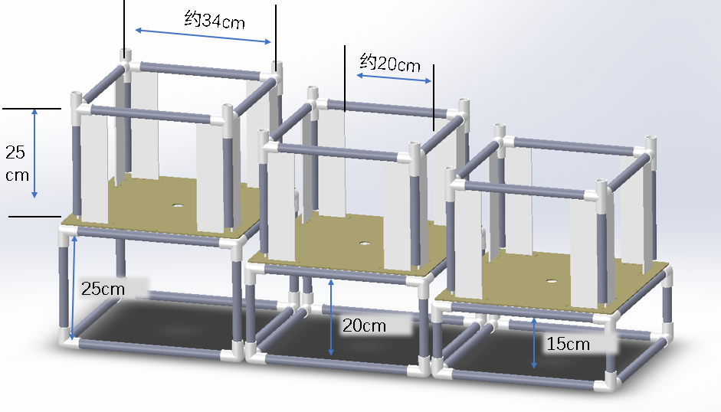

Figure 25 Reef Gaps Diagram

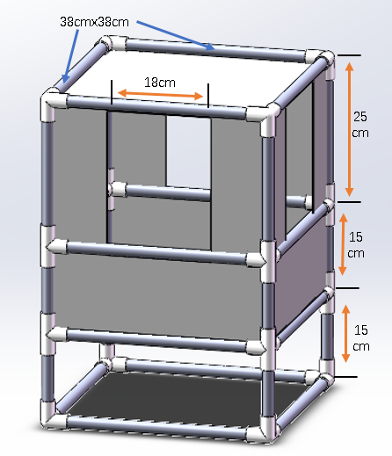

Figure 26 Collection Cell Diagram

## 2.4 Precise Operation

The team operators control the ROV to remove the connector from the “elevator”, insert the connector into the seabed detector which is then started by the rotary switch. In this task, the interface of the seabed detector is set in three types: large, medium and small, and different types of interfaces are inserted to obtain different scores.

Specific tasks:

1.Obtaining the connector from the “elevator”(a T-shaped plug about 24cm long and 12cm wide)

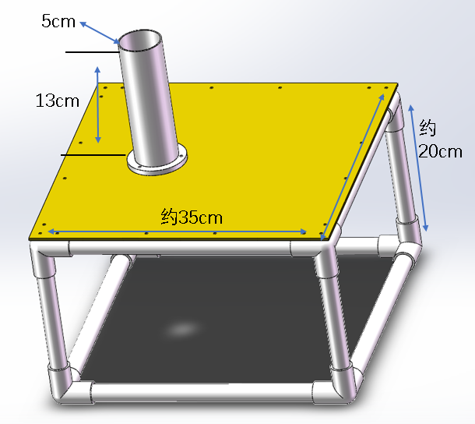

Figure 27 Elevator Diagram

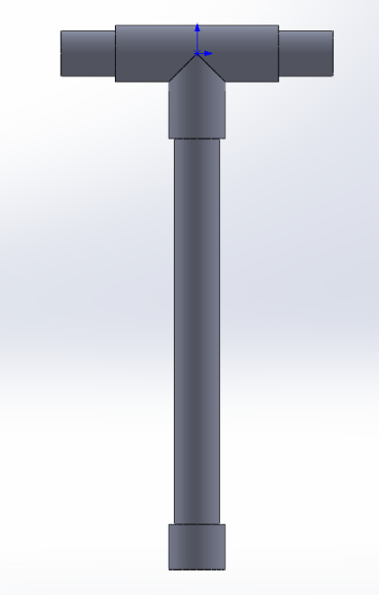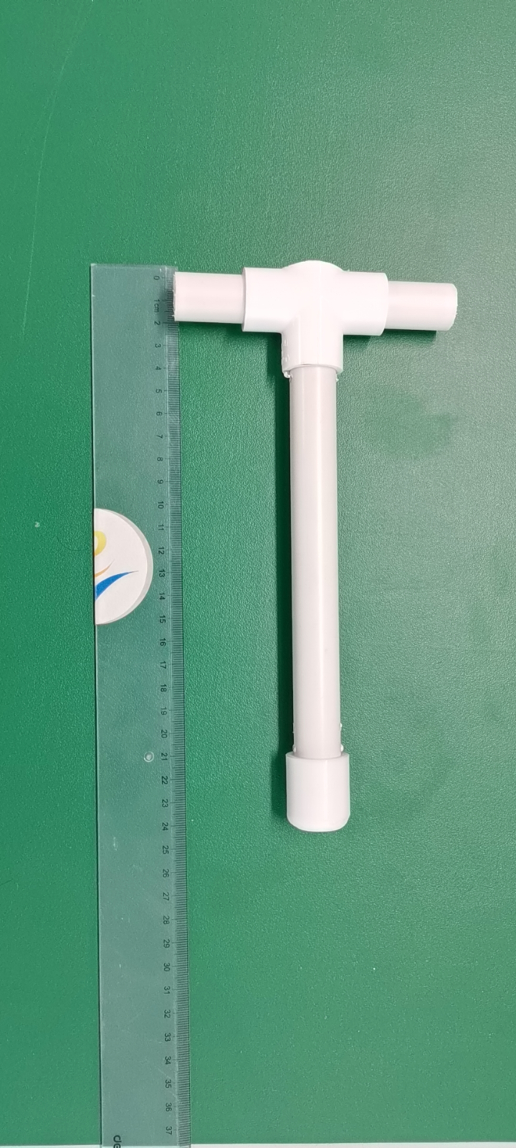

Figure 28 Connector(T-shaped Plug) Diagram

1. Inserting the connector into the seabed detector interface(small-medium-large: 30mm-60mm-90mm)

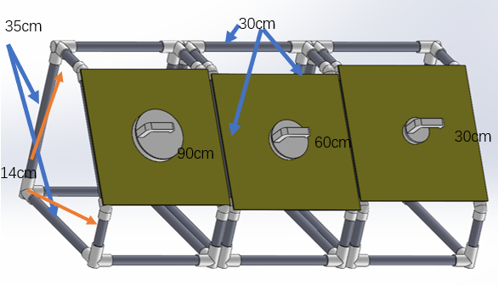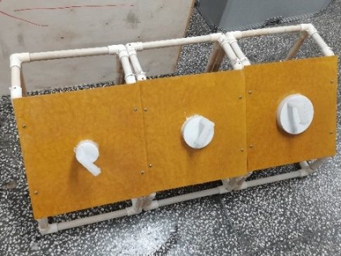

Figure 29 Seabed Detector Interface Diagram

1. Turning the rotary switch 180 degrees to start the seabed detector.

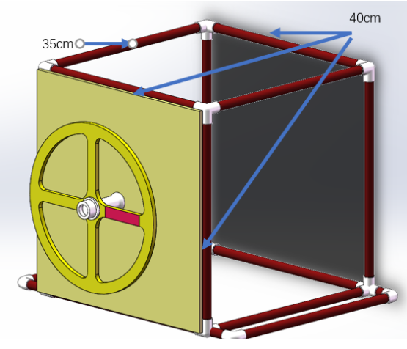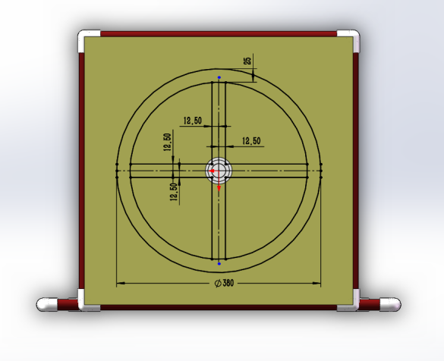

Figure 30 Rotary Switch Diagram

## 2.5 End of Competition

After completing all tasks, the vehicle immediately surfaces and team members apply for the end of the competition. When the vehicle surface, the minute timer for 10 minutes stops. The rest of time is converted into "remaining time bonus".

The above figures are for reference only, the competition is subject to the actual.

The organizing committee reserves the right of final interpretation.

# 3.Scoring Criteria

The total score consists of operation scores completed within 10 minutes and bonus points. The bonus points can only be scored if all tasks are completed within 10 minutes. The competition result is sorted according to the total score. If the scores are the same, the team with lower quality wins.

|  |  |  |
| --- | --- | --- |
| Task | Score | Maximum |
| Task 1：Feeds Delivery | | 50 |
| Delivering the feed container into the area | 20points | 20 |
| Delivering the ball solid feed into the area | 10points/ each | 30 |
| Task 2：Inspecting the Hull | | 60 |
| Hang 1 /2 /3 blue objects correctly at the end of the competition | +5/+15/+30 | 30 |
| Hang 1 /2 /3 red objects correctly at the end of the competition | +5/+15/+30 | 30 |
| Task 3： Collecting Seabed Ore | | 45 |
| Placing the ore in the reef gaps in the collection cell | 15 points /each | 45 |
| Task 4：Underwater Precise Operation | | 30 |
| Removing the plug from the "elevator" | 5 points | 5 |
| Inserting plug into the interface | 5 /10 /15 points | 15 |
| Turning switch more than 180 degrees | 10 points | 10 |
| Others | | 10 |
| Additional points for the remaining time(rounded) | 1 point /10second | 10 |
| Total | 200 | |

1. **Innovative Concept Track Rules**

# 1. Requirements

The Prototype Track introduces and demonstrates the design of underwater robots. The design should be based on the operation tasks and technical requirements of AUV/ROV track, and the concept design of assembly, parts and key technologies should be carried out.

The design scheme should be innovative in functional principle or layout. The main innovation points, calculation process, design drawings, implementation approaches, application analysis, etc., shall be introduced. The design scheme shall not exceed 25 pages (in addition, the technical introduction part shall not contain the name and logo of the participating unit, so as to facilitate the organization of blind online evaluation).

Teams are encouraged to submit functional demonstration videos, which can be physical functional demonstration or 3D model demonstration. Video production can be prepared in two versions, demo version length should not exceed 2 minutes, file size should not exceed 200M; The full version should be no longer than five minutes and the file size should not exceed 1 G.

The design scheme or videos shall not contain any content involving state secrets and shall be reviewed by the participating units.

# Rules of Competition

## 2.1 Competition Process

The team will draw to decide the order of defense through network broadcast. After the announcement of defense order, the defense team can enter the waiting room in advance, and each team will defend in turn. According to the team defense and the work design scheme, the result of the competition is determined.

The total defense time shall not exceed 10 minutes, among which the work exposition time shall not exceed 5 minutes.

The respondent must be a member of the team and cannot be replaced by others outside the team.

## 2.2 Scoring Criteria

The scoring rules are as follows:

|  |  |  |
| --- | --- | --- |
| Index item | Percentage | Index Connotation |
| Innovation and Uniqueness | 40% | Original and innovative structure, reflected in solving similar tasks with new methods or solving tasks that have not been conquered. |
| Feasibility and Application Value | 30% | Reasonable design, clear implementation plan, the possible task capability and characteristics, application prospect, engineering feasibility, etc |
| Text and Delivery | 20% | Strong logic, clear hierarchy, clear arguments and arguments, detailed theoretical analysis and experimental data |
| Defense Performance | 10% | Concise and refined language expression, clear logic and good performance. |

The organizing committee reserves the right of final interpretation.